CODER BUDDY
Local LLM-Based Automated Detection and Correction of Secure Coding Violations and AI-Powered Project Generation

A PROJECT REPORT
Submitted in partial fulfilment of the requirements for
SOFTWARE ENGINEERING (CA 725)

Submitted by
Sanket Yadav — 205125094 Himanshu Choudhary — 205125040
Under the Guidance of
Ms. Rajalakshmi Ma’am



NATIONAL INSTITUTE OF TECHNOLOGY
TIRUCHIRAPPALLI – 620015 DEPARTMENT OF COMPUTER APPLICATIONS
October 2026

DECLARATION
We declare that the project report entitled “Coder Buddy: An AI-Powered Project Generator and Secure-Coding Scanner and Fixer” is submitted to the Department of Computer Applications, National Institute of Technology Tiruchirappalli, in partial fulfilment of the requirements for Software Engineering (CA 725).
Place: NIT Tiruchirappalli Date: 28/10/2026

Sanket Yadav Roll No.: 205125094 | Himanshu Choudhary Roll No.: 205125040
Department of Computer Applications NIT Tiruchirappalli | Department of Computer Applications NIT Tiruchirappalli

CERTIFICATE
This is to certify that the project report entitled “Coder Buddy: An AI-Powered Project Generator and Secure-Coding Scanner and Fixer”, submitted by Sanket Yadav Roll no. 205125094 and Himanshu Choudhary Roll no. 205125040 to the Department of Computer Applications, National Institute of Technology Tiruchirappalli, is a record of project work submitted in partial fulfilment of the requirements for Software Engineering (CA 725).

Ms. Rajalakshmi ma’am  Project Guide  Department of Computer Applications | Dr. S. Dominic  Head of the Department  Department of Computer Applications

ACKNOWLEDGEMENTS
We express our sincere gratitude to Ms. Rajalakshmi Ma’am, Department of Computer Applications, National Institute of Technology Tiruchirappalli, for her guidance and support throughout the development of this project.
We are thankful to the Department of Computer Applications for providing the academic environment and opportunity to undertake this project as part of Software Engineering (CA 725).
We also acknowledge the contributions of the open-source software ecosystem and the developers of the libraries and tools used in the project. These tools supported the implementation of the multi-agent workflow, user interface, file operations, security analysis, and automated testing.

Sanket Yadav— 205125094
Himanshu Choudhary— 205125040

ABSTRACT
Software development involves several activities, including requirement analysis, system design, code implementation, and security testing. Performing these activities manually can require considerable time and effort, particularly when developers must repeatedly create project files and identify potential security weaknesses. Coder Buddy is a Python-based application designed to simplify project development through AI-assisted code generation and secure-coding analysis.

The project uses a multi-agent architecture consisting of Planner, Architect, and Coder agents. The Planner interprets the user's natural-language requirements and develops a project plan. The Architect organizes the plan into implementation tasks and determines the required files. The Coder executes these tasks using controlled file-management tools to generate the project. The application provides a Streamlit-based graphical interface and a command-line interface.

In addition to project generation, Coder Buddy provides a secure-coding scanner and automated correction functionality. The scanner combines deterministic security rules with optional large language model analysis to identify potential coding weaknesses. Findings can be associated with security references such as Common Weakness Enumeration (CWE), the OWASP Top 10, and CERT C/C++ guidelines, where applicable. The system validates model-generated findings against the source code, applies eligible corrections, checks syntax where supported, and rescans modified files to determine whether reported violations remain.

The application supports local model execution through Ollama and cloud-based model access through Groq. It also provides safeguards for uploaded source code, including archive validation and protection against unsafe file operations. The project was tested using a pytest-based automated test suite. The recorded test execution completed with 198 passed tests, 2 skipped tests, and 1 deselected test.

Coder Buddy demonstrates how AI-assisted development and security analysis can be integrated into a single application. However, its findings are not guaranteed to represent exploitable vulnerabilities, and its automated corrections require appropriate review. The application is intended to assist developers rather than replace professional security auditing or comprehensive static application security testing.

Keywords: Artificial Intelligence, Multi-Agent Systems, Code Generation, Secure Coding, Vulnerability Detection, Automated Code Correction, Python, LangGraph, Streamlit, Ollama.

TABLE OF CONTENTS
Abstract 5
List of Figures 7
List of Tables 8
List of Abbreviations 9
CHAPTER 1: Introduction 10
  - Background 10
  - Problem Statement 10
  - Objectives 11
  - Scope of the Project 11
  - Motivation 12
  - Proposed System 12
CHAPTER 2: Requirements Analysis and System Design 13
  - Requirements Analysis 13
  - Functional Requirements 13
  - Non-Functional Requirements 14
  - Feasibility Study 15
  - System Architecture 16
  - Module Description 17
  - Data Flow 18
  - Security Considerations 19
CHAPTER 3: Implementation and Testing 20
  - Technologies and Tools 20
  - Implementation of Project Generation 21
  - Implementation of Secure-Coding Analysis 21
  - Automated Code Correction 22
  - User Interface 23
  - Testing Methodology 23
  - Test Results 24
CHAPTER 4: Results, Conclusion and Future Scope 26
  - Results 26
  - Advantages 27
  - Limitations 28
  - Conclusion 28
  - Future Scope 29
References 31

LIST OF FIGURES
- Figure 2.1: Architecture of Coder Buddy
- Figure 3.1: Coder Buddy project-generation interface
- Figure 3.2: Model configuration and project generation in the Streamlit interface

LIST OF TABLES
- Table 2.1: System Functional Requirements Specification
- Table 2.2: System Non-Functional Requirements Specification
- Table 3.1: Technologies and Tools
- Table 3.2: Test Categories

LIST OF ABBREVIATIONS

Abbreviation | Full Description
AI | Artificial Intelligence
API | Application Programming Interface
CA | Course code used for Software Engineering
CLI | Command-Line Interface
CWE | Common Weakness Enumeration
HTML | HyperText Markup Language
LLM | Large Language Model
NIT | National Institute of Technology
OWASP | Open Worldwide Application Security Project
pytest | Python testing framework
REST | Representational State Transfer
UI | User Interface

CHAPTER 1: Introduction

Background
Software development is a structured process involving requirement identification, planning, architecture design, implementation, testing, and maintenance. Developers must translate user requirements into working applications while ensuring that the resulting code is understandable, maintainable, and secure.
Traditional development workflows often require developers to create project structures manually, determine the files required for each feature, implement the necessary functionality, and inspect the code for potential weaknesses. These activities can become repetitive and time-consuming, particularly when developing small applications, prototypes, or demonstration projects.
Artificial Intelligence (AI), particularly Large Language Models (LLMs), has introduced new approaches to software development. These models can interpret natural-language instructions, generate source code, explain programming concepts, and assist in identifying potential coding issues. When combined with workflow orchestration and controlled tools, AI models can be organized into multiple agents that perform distinct responsibilities.
However, generated source code may contain errors, incomplete functionality, insecure coding patterns, or unsuitable implementation choices. Therefore, code generation alone is insufficient for a reliable development workflow. A mechanism is also needed to inspect generated or existing code and help developers correct potential security problems.
Coder Buddy addresses these needs by combining AI-assisted project generation with secure-coding analysis and automated correction. It provides a unified interface through which users can describe a project, generate its initial structure, scan source code, review potential violations, and attempt eligible corrections.

Problem Statement
Developers frequently encounter two related challenges: the time required to transform application requirements into a structured codebase and the difficulty of consistently identifying security weaknesses during development.
Manual project creation requires developers to plan files, organize implementation tasks, and write repetitive code. Although AI-based code generation can reduce this effort, generated code may still contain insecure patterns or implementation errors.
Security analysis introduces another challenge. Developers must understand relevant coding guidelines, examine source files, identify potentially unsafe constructs, and verify that corrections do not introduce new problems. These activities may require specialized knowledge and additional tools.
There is therefore a need for an integrated system that can:
    - Convert natural-language project descriptions into structured implementation plans.
    - Generate project files through coordinated AI agents.
    - Analyse generated or existing source code for potential secure-coding violations.
    - Suggest or apply corrections while preserving safeguards around file operations.
    - Validate corrections through source-code checks and subsequent scans.
    - Present results through an accessible graphical interface and a command-line interface.

Coder Buddy is developed to address these requirements through an AI-assisted project generation and secure-coding workflow.

Objectives
The primary objective is to develop an integrated application that supports automated project generation and secure-coding analysis.
The specific objectives are:
- To accept project requirements expressed in natural language.
- To divide project generation into planning, architecture, and coding stages.
- To generate project files through controlled file-management tools.
- To provide a graphical interface for project generation and code scanning.
- To support both cloud-based and locally executed language models.
- To identify potential security weaknesses using deterministic rules and optional LLM-based analysis.
- To associate applicable findings with established security references.
- To validate model-generated findings against actual source-code content.
- To apply eligible corrections with safeguards and preserve recoverable copies of modified files.
- To rescan modified code and determine whether identified violations remain.
- To provide machine-readable and human-readable scan reports.
- To evaluate the application using automated tests.

Scope of the Project
The scope of Coder Buddy includes the following components.
AI-assisted project generation: The system interprets a natural-language prompt and produces a project plan, an ordered implementation plan, and the corresponding source files.
Multi-agent coordination: The project generation process is divided among Planner, Architect, and Coder agents to separate responsibilities and organize implementation tasks.
Secure-coding analysis: The system examines source code using deterministic rules and optional LLM-based analysis. Supported languages include Python, JavaScript, TypeScript, HTML, C, and C++, with additional languages handled through applicable generic rules and model-based analysis.
Automated correction: Eligible violations can be corrected through controlled patching, validation, backup creation, and rescanning.
Multiple interfaces: Users can interact with the system through a Streamlit graphical interface or a command-line workflow.
Model flexibility: The system supports local inference through Ollama and cloud-based inference through Groq.
Security safeguards: The system incorporates protections for uploaded archives, source-code handling, file modifications, and model-generated findings.
The project does not guarantee that all vulnerabilities will be detected or that all corrections will be safe in every execution environment. Its findings and patches should be reviewed before deployment in production systems.

Motivation
The motivation behind Coder Buddy is to reduce the effort involved in repetitive development tasks while encouraging secure coding practices.
AI-assisted development tools can generate code quickly, but the quality and security of generated code remain important concerns. An application that combines generation and security analysis can help developers examine potential weaknesses earlier in the development process.
The project also explores the use of multi-agent systems, in which different agents perform specialized tasks rather than relying on one undivided generation step. This separation can improve workflow organization and make the responsibilities of individual stages easier to understand.
Another motivation is the availability of local language models. By supporting Ollama, Coder Buddy allows users to perform model inference locally, subject to the selected model's capabilities and configuration.
Cloud-based inference remains available as an alternative.

Proposed System
Coder Buddy consists of two major functional areas: project generation and secure-coding analysis.
During project generation, the user enters a natural-language description. The Planner converts the description into a structured plan. The Architect converts that plan into implementation tasks, including the files required for the project. The Coder processes these tasks and uses file-management tools to create the source files.
During secure-coding analysis, the user can scan code generated by the application or provide an existing project for examination. Deterministic security rules identify known coding patterns, while optional LLM analysis can examine additional context. Model-generated findings are checked against the source code before being accepted.
If automatic correction is enabled, the system attempts to generate and validate patches for eligible findings. Modified files are backed up, applicable syntax checks are performed, and the files are rescanned. The process repeats within a configured correction-round limit.
The application presents the generated project information, scan findings, and available reports through its user interface and command-line functionality.

CHAPTER 2: Requirements Analysis And System Design

Requirements Analysis
Requirements analysis identifies the functionality and quality characteristics required from the proposed application.
Coder Buddy must support project generation, file management, secure-coding analysis, optional automated correction, report generation, and interaction with different LLM providers. It must also protect user files and avoid treating unverified model-generated findings as confirmed vulnerabilities.
The system is implemented primarily in Python and uses a multi-agent workflow for project generation. Security analysis is handled through a combination of deterministic rules and optional model-assisted analysis.

Functional Requirements
The functional requirements describe the operations that the system must perform.

ID | Functional requirement | Description
FR1 | Accept project requirements | The system accepts natural-language descriptions of the desired application.
FR2 | Plan the project | The Planner produces a structured project plan.
FR3 | Design implementation tasks | The Architect determines the implementation sequence and required files.
FR4 | Generate source files | The Coder creates files using controlled file-management tools.
FR5 | Support user interfaces | The application provides Streamlit and command-line interaction.
FR6 | Scan source code | The system examines generated or existing source code for potential violations.
FR7 | Apply security rules | Deterministic rules identify applicable insecure coding patterns.
FR8 | Perform model-assisted analysis | The system can use an LLM to identify additional potential issues.
FR9 | Validate findings | Model-generated findings are checked against actual source-code content.

FR10 | Correct eligible violations | The system can generate and apply validated corrections when automatic fixing is enabled.
FR11 | Verify corrections | Modified files are rescanned to determine whether the reported violations remain.
FR12 | Generate reports | The system provides scan information in JSON and Markdown formats.
FR13 | Support model providers | The system supports configured Groq and Ollama providers.
FR14 | Protect source files | Existing projects can be scanned using a copy so that the original files remain untouched by the scan-and-fix workflow.

Non-Functional Requirements

ID | Requirement | Description
NFR1 | Usability | The graphical interface should make project generation and scanning accessible to users.
NFR2 | Maintainability | The application should separate workflow, security rules, file operations, and interface functionality into modules.
NFR3 | Reliability | Invalid or malformed model outputs should be handled through validation and appropriate error-handling mechanisms.
NFR4 | Security | File operations and code modifications should be restricted and validated.
NFR5 | Portability | The Python application should run in a compatible environment with the required dependencies.
NFR6 | Model flexibility | The application should support configured local and cloud-based LLM providers.

NFR7 | Traceability | Security findings should provide useful information about the affected code and applicable security references.
NFR8 | Recoverability | The correction workflow should preserve backups before modifying files.
NFR9 | Testability | The application should support automated testing of its major components.
NFR10 | Transparency | Scan findings and correction results should be available for review rather than being treated as unquestionable security guarantees.

Feasibility Study

Technical Feasibility
The project is technically feasible using Python and its supporting libraries. LangGraph provides workflow orchestration for the multi-agent generation process, while Streamlit supports the graphical interface.
The secure-coding component combines deterministic rules with LLM-based analysis. Ollama provides access to local models, while Groq supports cloud-based inference. The system also uses automated testing tools to validate its implemented functionality.
The application can be executed on a compatible computer with Python and the necessary dependencies. Local model execution additionally requires a suitable model installation and sufficient system resources.

Economic Feasibility
The project uses Python and several open-source libraries, which reduces the initial software licensing requirements. Local inference through Ollama can reduce dependence on paid cloud inference, although hardware usage and electricity costs remain relevant.
Cloud inference through Groq may be subject to provider-specific access limits, usage quotas, or pricing. The overall cost therefore depends on the selected model provider, hardware configuration, and frequency of use.

Operational Feasibility
The application offers a graphical interface for users who prefer interactive operation and a command-line interface for terminal-based workflows. This makes the system usable for demonstrations, development experiments, and code-review assistance.
However, users should understand the limitations of automated security analysis and review proposed changes before relying on them in production environments.

System Architecture
Coder Buddy follows a modular architecture in which project generation and secure-coding analysis are connected through the application interface.

Architecture Components
- User Interface Layer
The user interacts with the application through Streamlit or the command-line interface. The user provides a project prompt, selects relevant settings, initiates generation or scanning, and reviews the results.
- Agent Orchestration Layer
LangGraph coordinates the project generation workflow. The workflow organizes planning, architecture, coding, and relevant state transitions.
- Planner Agent
The Planner interprets the user's requirements and generates a structured plan describing the intended project.
- Architect Agent
The Architect converts the project plan into an ordered set of implementation tasks. Each task identifies work required to construct part of the application.
- Coder Agent
The Coder executes the implementation tasks. It uses controlled tools such as read_file, write_file, list_files, and get_current_directory to interact with project files.
- LLM Provider Layer
The system supports configured model providers, including Groq for cloud inference and Ollama for local inference. The selected provider is used according to the operation and application configuration.
- Secure-Coding Analysis Layer
The security layer combines deterministic rules and optional LLM-based analysis. Findings are validated against the actual source code before being accepted.
- Correction and Verification Layer
Eligible corrections are checked before application. The system preserves backups, performs applicable syntax validation, applies patches, and rescans modified files.
- Reporting Layer
The application produces scan reports in JSON and Markdown formats, providing information about detected findings and correction outcomes.

Architecture Diagram
Figure 2.1: Architecture of Coder Buddy
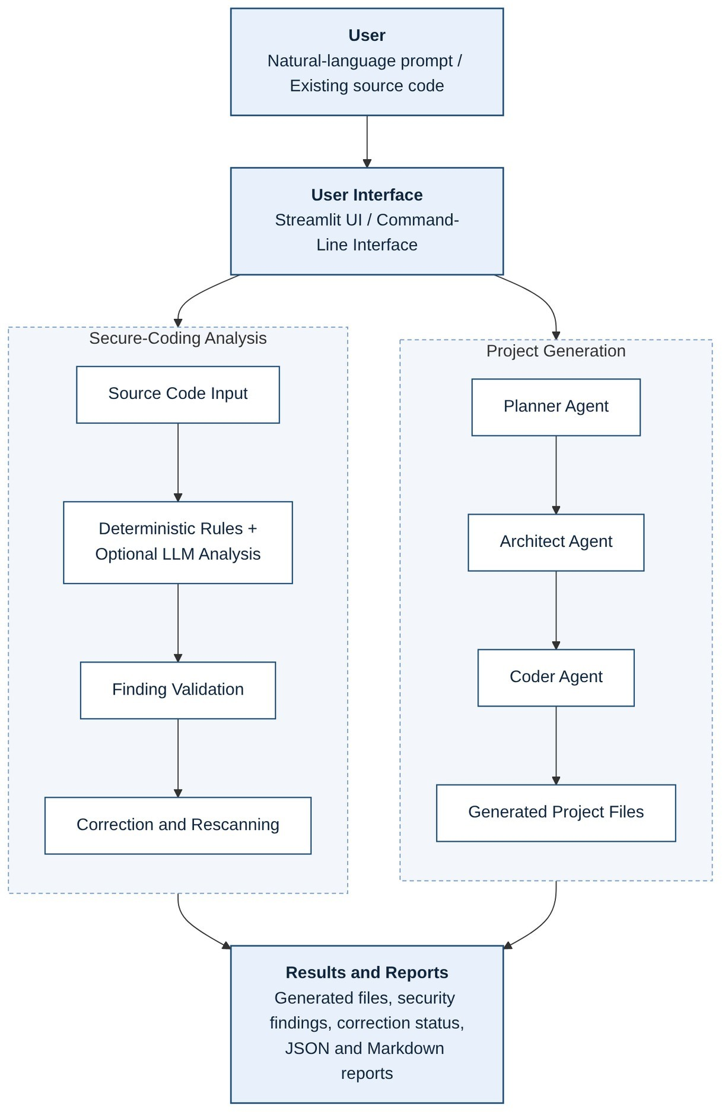

The diagram represents the major functional stages of the system. The project generation workflow creates application files, while the secure-coding workflow examines generated or existing code. The results are presented to the user through the interface and reporting mechanisms.

Module Description

Agent Workflow Module
The agent workflow coordinates the project generation process. It manages the sequence of planning, architecture creation, and coding tasks. The workflow also handles state transitions and supports retry or fallback behaviour when model-generated tool outputs are malformed.

State Management Module
The project uses structured state models to represent information exchanged between agents. These models help maintain consistency between planning, implementation tasks, and generated outputs.

LLM Integration Module
The LLM integration module manages access to configured model providers. It supports local and cloud inference and provides the model interactions required by the generation and analysis workflows.

File Management Module
The file management module provides controlled operations for reading, writing, and listing files. Generated project files are restricted to the designated project workspace, helping prevent unintended file modifications outside the intended working area.

Security Rules Module
The security rules module contains deterministic checks for known insecure coding patterns. These rules provide predictable detection behaviour for supported patterns and can associate findings with relevant security references.

Secure-Coding Analysis Module
The secure-coding module coordinates rule-based checks and optional model-assisted analysis. It validates model-generated findings against source-code excerpts and line information before accepting them.

Correction Module
The correction module attempts to generate and validate patches for eligible findings. It preserves backups, applies changes through controlled operations, and verifies the result by rescanning the affected files.

Reporting Module
The reporting module records scan results and correction information in JSON and Markdown formats. These reports support further inspection of the findings and their status.

Data Flow
The application supports two main data flows.

Project Generation Data Flow
- The user enters a project description.
- The Planner interprets the description and creates a project plan.
- The Architect converts the plan into ordered implementation tasks.
- The Coder processes the tasks and generates project files.
- The application displays the generated project information and available files.
- If enabled, the generated code can be passed to the secure-coding workflow.

Secure-Coding Data Flow
- The user selects generated code or supplies an existing project.

- The application prepares the source code for analysis.
- Deterministic security rules examine the relevant files.
- Optional LLM analysis identifies additional potential issues.
- Model-generated findings are validated against the source code.
- Accepted findings are presented to the user.
- If automatic correction is enabled, eligible findings are passed to the correction workflow.
- Patches are validated and applied with backup safeguards.
- Modified files are rescanned.
- The application records the results and generates reports.

Security Considerations
Security is an important part of the system because the application processes source code and may modify files automatically.
Source-code validation: Model-generated findings must correspond to actual code in the source files. This reduces the risk of accepting unsupported findings.
Controlled file operations: Project generation uses designated workspaces and controlled file tools. Backup creation: The correction workflow preserves copies of files before applying modifications.
Patch validation: Proposed patches are checked before application, with syntax validation where supported. Rescanning: Modified files are rescanned to determine whether the original violations remain.
Uploaded archive protection: The application incorporates checks for unsafe archive paths, symbolic links, and archive-size risks.
Prompt-injection mitigation: Source code is treated as untrusted input during scanning and correction. Scan and fix model calls are designed without general file-operation tools.
Local inference option: Ollama allows users to perform supported model operations locally, reducing the need to transmit source code to a cloud model provider. Cloud-based inference should be selected with awareness of applicable data-handling requirements.
These safeguards reduce certain operational risks but do not establish that every scan or correction is secure in every environment.

CHAPTER 3: Implementation And Testing

Technologies and Tools
The following technologies and tools are associated with the Coder Buddy implementation.

Technology or tool | Purpose
Python | Primary programming language
LangGraph | Orchestration of the multi-agent project generation workflow
Streamlit | Graphical user interface
Groq | Cloud-based LLM inference provider
Ollama | Local LLM execution
openai/gpt-oss-120b | Cloud model identified in the project configuration
qwen2.5-coder:3b | Local model shown in the supplied application screenshot and testing environment
Pydantic | Structured data models and state validation
Pytest | Automated testing
Git | Version control, if used in the development workflow
JSON | Structured scan-result reporting
Markdown | Human-readable scan reports
HTML, CSS and JavaScript | Languages supported by project-generation examples and relevant code-analysis rules
CWE | Classification of common software weaknesses
OWASP Top 10:2021 | Reference for major web application security risks
CERT C/C++ | Secure-coding guidance for C and C++
Windows | Operating environment shown in the supplied testing output

The AI tools directly associated with the application's model functionality are Groq and Ollama. The supplied application screenshot shows Ollama configured with qwen2.5-coder:3b. ChatGPT was also used in preparing this report. Other AI-assisted development tools should be listed only if they were actually used during implementation; their use cannot be established from the project files supplied here.

Implementation of Project Generation
The project generation component converts natural-language requirements into a structured project implementation.

Input Processing
The user describes the desired application in a text prompt. For example, the supplied screenshot shows the prompt:
“Create a colourful landing page for a coffee shop in html, css and js.”
The prompt identifies the expected application and its principal technologies. The system passes the requirements through the agent workflow.

Planning
The Planner interprets the user's request and prepares a structured plan describing the intended project. This provides a basis for the subsequent architecture and coding stages.

Architecture Generation
The Architect transforms the project plan into an ordered collection of implementation tasks. These tasks specify the work required to create the project files.

Code Generation
The Coder processes the implementation tasks and uses controlled file-management tools to create source files. The generated project is stored in the designated project workspace.

Workflow Monitoring
The application displays the completion status of the Planner, Architect, and Coder stages. In the supplied screenshot, all three stages display a completed status for the coffee shop landing-page example.
This demonstrates a successful completion of the displayed generation workflow, but it does not independently establish that every generated file is functionally correct or free from security weaknesses.
Figure 3.1: Coder Buddy project-generation interface

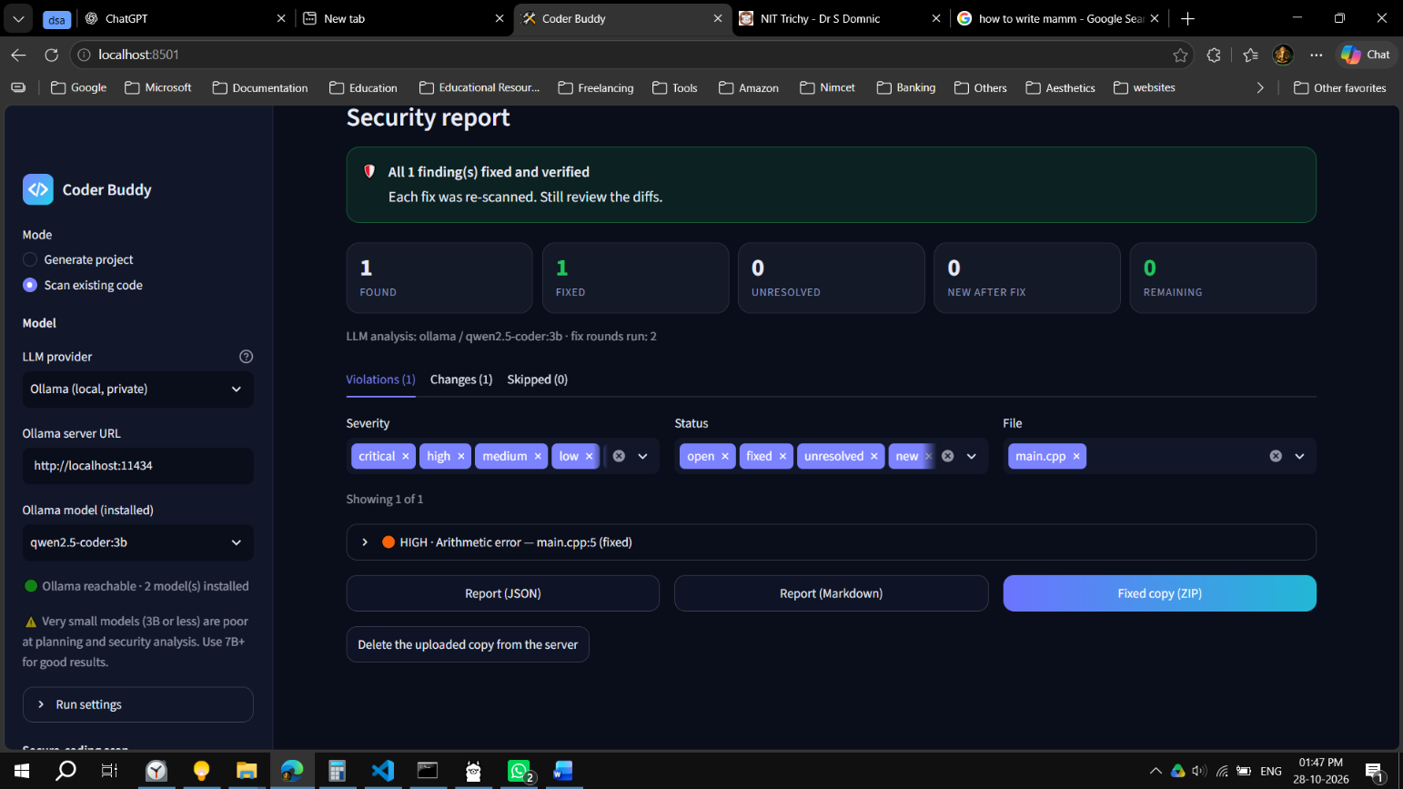

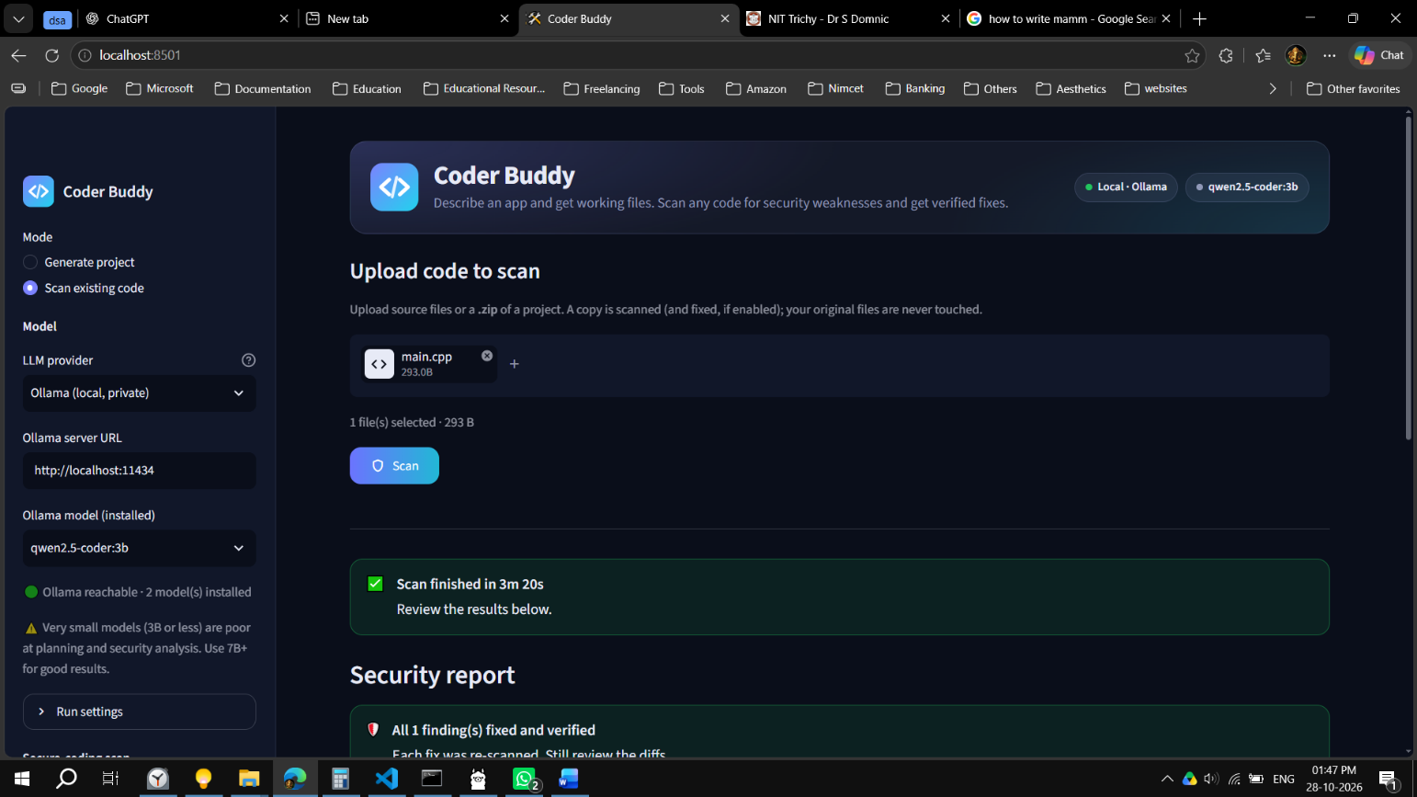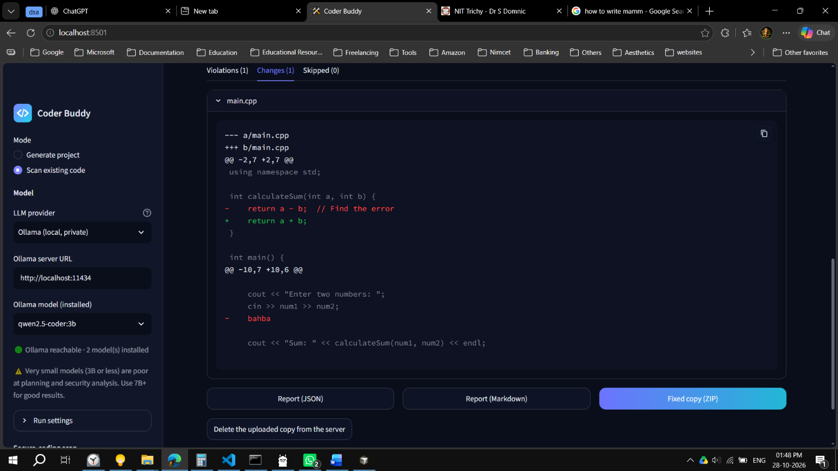

Implementation of Secure-Coding Analysis
The secure-coding component examines source code for potential weaknesses. It combines deterministic rules with optional LLM-based analysis.

Deterministic Rule-Based Analysis
Deterministic rules identify known patterns associated with potentially insecure coding practices. Because these checks follow defined conditions, they can provide predictable results for the patterns they cover.
The rule-based approach is useful for identifying known issues without requiring every finding to be generated by a language model. However, its coverage depends on the available rules and their implementation.

LLM-Based Analysis
An optional LLM examines source code to identify additional potential security issues. Model-assisted analysis can consider contextual patterns that may not be covered by a specific deterministic rule.
However, language models can produce inaccurate findings or suggest inappropriate corrections. Consequently, model output is not accepted without validation.

Finding Validation
The system validates model-generated findings by requiring quoted code to match the actual source file. It also checks applicable line-range information.
This validation helps reject findings that refer to code not present in the scanned source. It does not prove that every accepted finding is exploitable or that every reported weakness is security-critical.

Security References
Where applicable, findings can be associated with references such as:
      - Common Weakness Enumeration (CWE).
      - OWASP Top 10:2021.
      - CERT C/C++ secure-coding guidelines.
These references provide a structured way to describe and classify potential weaknesses. Their availability and relevance depend on the rule or finding being reported.

Automated Code Correction
The correction component attempts to address eligible security findings. The correction workflow includes the following stages:
- Select a finding eligible for automatic correction.
- Generate a proposed patch.
- Validate the patch against the intended source-code change.
- Perform applicable syntax checks.
- Preserve a backup of the file before modifying it.
- Apply the validated patch through controlled file operations.
- Rescan the modified file.
- Record whether the original violation remains.
When scanning an existing project, the workflow uses a copy so that the original source files remain untouched by the scan-and-fix process.
The application uses a configurable correction-round limit. The project configuration described in the README uses a default of two rounds, with a maximum of five.
The system treats a violation as fixed only when the subsequent scan no longer reports that violation. This is an operational verification mechanism rather than proof that the entire file or application is free from vulnerabilities.

User Interface
Coder Buddy provides a Streamlit-based interface and a command-line interface.
The Streamlit interface includes controls for selecting the operating mode, configuring the LLM provider, specifying the model, entering a project prompt, and enabling relevant security options.
The supplied screenshot shows the following configuration:
- Mode: Generate project.
- LLM provider: Ollama (local).
- Model: qwen2.5-coder:3b.
- Ollama server URL: http://localhost:11434.
- Recursion limit: 100.
- Clear previous generated files first: Enabled.
- Run secure-coding scan after generation: Disabled.
- Fix violations automatically: Enabled.
The screenshot also displays the completed Planner, Architect, and Coder stages and a generated project titled “Coffee Shop Landing Page.”
These settings represent the configuration shown in that particular screenshot and should not be interpreted as the mandatory settings for every execution.
Figure 3.2: Model configuration and project generation in the Streamlit interface

Testing Methodology
Testing was conducted using the pytest framework in a Windows environment with Python 3.11.15.
The test suite covers application startup behaviour, command-line functionality, graph routing, LLM parsing, security rules, finding validation, application state, and uploaded-file safety.
The following command was executed:
pytest
The recorded output indicates that 201 tests were collected, with one deselected and 200 selected for execution. The execution completed with 198 passed tests and 2 skipped tests.

Test Categories

Test module | Purpose
test_app_smoke.py | Basic application smoke tests
test_cli.py | Command-line behaviour
test_graph_routing.py | Agent workflow routing
test_llm_parsing.py | Parsing and handling of LLM outputs

test_rules.py | Deterministic security-rule checks
test_secure_validation.py | Security finding and correction validation
test_states.py | State-model behaviour
test_upload_safety.py | Uploaded-file and archive safety

The test suite exercises important internal components and application workflows. However, the number of passed tests alone does not establish complete security coverage, production readiness, or the accuracy of every LLM-generated correction.

Test Results
The recorded test execution produced the following output:
platform win32 -- Python 3.11.15 Python 3.11.15
pytest-9.1.1

collected 201 items / 1 deselected / 200 selected

tests\test_app_smoke.py 6 passed
tests\test_cli.py 15 passed
tests\test_graph_routing.py 21 passed
tests\test_llm_parsing.py 34 passed
tests\test_rules.py 19 passed tests\test_secure_validation.py
38 passed, 2 skipped
tests\test_states.py 24 passed
tests\test_upload_safety.py 30 passed

198 passed, 2 skipped, 1 deselected
in 6.28 seconds
The output above reproduces the recorded overall result and test-module progress in a readable format. The final aggregate figures are taken from the supplied terminal log.

Summary of Automated Testing

198  Passed | 2  Skipped | 1  Deselected
Skipped Deselected
Execution time: 6.28 seconds. Environment: Windows, Python 3.11.15, pytest 9.1.1.
The test results indicate that the selected automated test suite completed successfully, with 198 tests passing and 2 tests skipped. One test was deselected and was not part of the selected execution.
The tests cover several important areas, including workflow routing, output parsing, deterministic security rules, finding validation, state management, and upload safety. These results provide evidence of functional testing for the tested components.

The skipped tests were not executed, so their behaviour cannot be considered verified by this run. Similarly, the deselected test is outside the reported selected-test results. The test outcome should therefore be interpreted in the context of the suite's actual coverage.
Figure 3.3: Automated test execution using pytest

CHAPTER 4: Results, Conclusion And Future Scope

Results
The project resulted in an integrated Python application for AI-assisted project generation and secure-coding analysis.

Project Generation
The application successfully completed the Planner, Architect, and Coder stages in the supplied coffee shop landing-page example. The interface displayed the project title, description, technology stack, and completed status for all three agents.
This demonstrates the intended multi-agent workflow in the displayed execution.

Secure-Coding Analysis
The application implements a hybrid analysis approach that combines deterministic security rules with optional LLM-based analysis. Findings can be checked against the source code before being accepted.
The design reduces reliance on unvalidated model output, although the effectiveness of detection remains dependent on rule coverage, model behaviour, and validation quality.

Automated Correction
The correction workflow supports validated patch application, backup creation, syntax checks where applicable, and rescanning of modified files. The system can repeat the correction process within a configurable limit.
This provides a structured mechanism for attempting to resolve eligible findings. It does not establish that every patch will be correct or that a successful rescan proves the absence of all security weaknesses.

Automated Testing
The recorded pytest run completed with 198 passed tests, 2 skipped tests, and 1 deselected test in 6.28 seconds.
The results demonstrate that the selected tests for application smoke behaviour, command-line operations, workflow routing, parsing, rules, security validation, state management, and upload safety completed with the reported outcome.

Overall Outcome
The project integrates project generation and secure-coding assistance into a single application. It provides a modular workflow, multiple interfaces, model-provider flexibility, safeguards for source-code modification, and automated test coverage.
The results support the feasibility of the implemented approach. Further testing with diverse real-world projects, independent security tools, and systematically measured correction outcomes would be required to evaluate its effectiveness more comprehensively.

Advantages

Reduced Manual Effort
The multi-agent generation workflow automates parts of project planning, architecture preparation, and source-file creation. This can reduce repetitive development work.

Modular Architecture
The Planner, Architect, and Coder agents have separate responsibilities. The modular design makes the workflow easier to understand and supports changes to individual components.

Integrated Security Analysis
Project generation and secure-coding analysis are available within the same application. Users can examine generated code or scan an existing project.

Hybrid Detection Approach
Combining deterministic rules with optional LLM-based analysis provides two complementary methods for identifying potential coding weaknesses.

Validation of Findings
Checking model-generated findings against actual source-code content helps reduce unsupported findings.

Automated Correction Support
The application can attempt corrections for eligible findings, preserve backups, and rescan modified files. This provides a more structured workflow than applying unverified model suggestions directly.

Local Model Support
Ollama enables local model execution when the required model and resources are available. This can be useful when source code should remain within the local environment.

Multiple Interfaces
The Streamlit interface supports interactive use, while the command-line interface supports terminal-based workflows.

Structured Reporting
JSON and Markdown reports provide machine-readable and human-readable representations of scan results.

Automated Testing
The pytest suite covers multiple application components, supporting repeatable validation of implemented behaviour.

Limitations

Incomplete Rule Coverage
Deterministic rules can identify only the patterns covered by their implementation. New vulnerabilities, complex data flows, and application-specific weaknesses may remain undetected.

Possible Inaccuracies in LLM Findings
Large language models may produce false positives, false negatives, or explanations that do not accurately describe the behaviour of the source code. Validation reduces some errors but cannot eliminate them completely.

No Guarantee of Exploitability Assessment
A detected pattern does not necessarily mean that a vulnerability is exploitable in the application's actual operating environment. Determining exploitability may require contextual analysis and expert review.

Risk of Incorrect Corrections
Automatically generated patches may alter program behaviour, introduce new defects, or fail to address the underlying security problem. Backup creation and rescanning reduce certain risks but do not eliminate them.

Dependence on Model Resources
Local model performance depends on hardware resources, model size, and inference speed. Cloud-based inference depends on network access and the availability and limits of the selected provider.

Language and Framework Coverage
The quality of analysis varies according to the available deterministic rules and the selected model's capabilities. Support for a programming language does not imply complete coverage of its vulnerabilities.

Limited Evaluation of Correction Quality
The supplied test output establishes the results of the automated test suite, but it does not provide a comprehensive quantitative measurement of vulnerability-detection accuracy, false-positive rate, false-negative rate, or the security correctness of applied patches.

Need for Human Review
The application is intended to assist development and security review. Developers should examine scan findings, inspect correction diffs, run relevant application tests, and review the resulting code before using it in production.

Conclusion
Coder Buddy was developed as an AI-assisted application that combines multi-agent project generation with secure-coding analysis and automated correction support.
The project generation workflow uses Planner, Architect, and Coder agents to transform natural-language requirements into structured implementation tasks and source files. The Streamlit interface and command-line functionality provide different ways to interact with the application.

The secure-coding component combines deterministic rules and optional LLM-based analysis. It validates model-generated findings against source-code content and supports controlled correction through patch validation, backup creation, applicable syntax checks, and rescanning.
The recorded automated test execution completed with 198 passed tests, 2 skipped tests, and 1 deselected test. This provides evidence of successful execution across the selected tests for several important application components.
The project demonstrates the practical integration of AI-assisted development and security-analysis workflows. At the same time, the limitations of deterministic rules, LLM-generated findings, and automatic correction must be considered. Coder Buddy should be treated as a development and security-assistance tool rather than a replacement for comprehensive security testing or expert review.
Overall, the project provides a foundation for further work in multi-agent software development, secure-code analysis, and automated correction workflows.

Future Scope
Several improvements can extend the capabilities of Coder Buddy.

Expanded Security Rule Catalogue
The deterministic rule catalogue can be extended to cover additional vulnerabilities, frameworks, programming languages, and secure-coding practices.

Integration with Established Security Tools
The system could integrate with established static-analysis and dependency-scanning tools to provide complementary findings and stronger coverage.

Improved Correction Evaluation
A systematic evaluation framework could measure correction success rates, regression frequency, false-positive rates, and false-negative rates using labelled datasets and controlled test projects.

Regression Testing After Corrections
The correction workflow could be extended to run project-specific unit tests, integration tests, and regression tests after applying patches.

Improved Finding Prioritisation
Findings could be prioritised using severity, confidence, exploitability indicators, and application context, provided these values are supported by reliable evidence.

Enhanced Reporting
Future versions could provide more detailed reports containing severity summaries, source-code excerpts, correction diffs, scan history, and comparative results before and after correction.

Better Model Selection
The application could support systematic model comparison based on inference time, resource consumption, finding accuracy, and correction quality.

Continuous Integration Support
Integration with continuous integration pipelines could allow projects to be scanned automatically during development. Such integration would require suitable configuration and controls to prevent unreviewed patches from being deployed.

Broader Project Validation
Future evaluation could use a larger collection of real-world projects and compare Coder Buddy's results with established security-analysis tools and expert assessments.

Improved User Guidance
The interface could provide more detailed explanations of findings, correction decisions, and validation outcomes to help users understand security issues and make informed decisions.

REFERENCES
- LangChain, “LangGraph Documentation.” Available: https://docs.langchain.com/oss/python/langgraph
- Streamlit, “Streamlit Documentation.” Available: https://docs.streamlit.io/
- Python Software Foundation, “Python 3 Documentation.” Available: https://docs.python.org/3/
- Pytest Developers, “pytest Documentation.” Available: https://docs.pytest.org/
- Ollama, “Ollama Documentation.” Available: https://docs.ollama.com/
- Groq, “Groq API Documentation.” Available: https://console.groq.com/docs/overview
- MITRE, “Common Weakness Enumeration (CWE).” Available: https://cwe.mitre.org/
- OWASP Foundation, “OWASP Top 10:2021.” Available: https://owasp.org/Top10/
- Software Engineering Institute, Carnegie Mellon University, “SEI CERT C Coding Standard.”
Available: https://wiki.sei.cmu.edu/confluence/display/c
- OpenAI, “GPT-OSS.” Available: https://openai.com/index/introducing-gpt-oss/

